**Лабораторная работа по курсу**

**«Разработка информационных систем»**

Лабораторная работа № 6

Виды соединений в операторе SELECT и создание представления

Выполнила: Сорокина П. О.

Группа: М8О-303Б-18

**Расположение созданной базы данных**

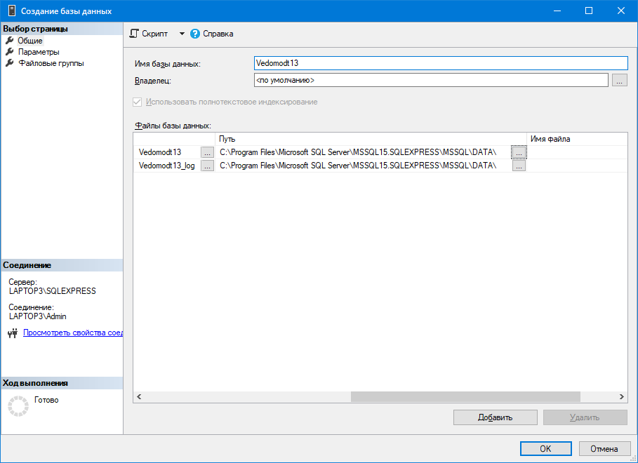

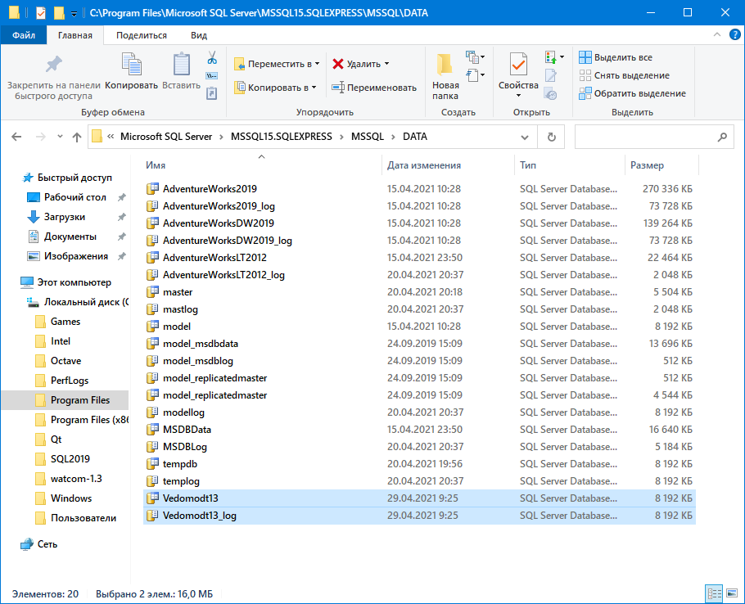

**SQL-скрипт VedomostNN**

USE [master]

GO

/****** Object: Database [Vedomodt13] Script Date: 29.04.2021 9:27:17 ******/

CREATE DATABASE [Vedomodt13]

CONTAINMENT = NONE

ON PRIMARY

( NAME = N'Vedomodt13', FILENAME = N'C:\Program Files\Microsoft SQL Server\MSSQL15.SQLEXPRESS\MSSQL\DATA\Vedomodt13.mdf' , SIZE = 8192KB , MAXSIZE = UNLIMITED, FILEGROWTH = 65536KB )

LOG ON

( NAME = N'Vedomodt13_log', FILENAME = N'C:\Program Files\Microsoft SQL Server\MSSQL15.SQLEXPRESS\MSSQL\DATA\Vedomodt13_log.ldf' , SIZE = 8192KB , MAXSIZE = 2048GB , FILEGROWTH = 65536KB )

WITH CATALOG_COLLATION = DATABASE_DEFAULT

GO

IF (1 = FULLTEXTSERVICEPROPERTY('IsFullTextInstalled'))

begin

EXEC [Vedomodt13].[dbo].[sp_fulltext_database] @action = 'enable'

end

GO

ALTER DATABASE [Vedomodt13] SET ANSI_NULL_DEFAULT OFF

GO

ALTER DATABASE [Vedomodt13] SET ANSI_NULLS OFF

GO

ALTER DATABASE [Vedomodt13] SET ANSI_PADDING OFF

GO

ALTER DATABASE [Vedomodt13] SET ANSI_WARNINGS OFF

GO

ALTER DATABASE [Vedomodt13] SET ARITHABORT OFF

GO

ALTER DATABASE [Vedomodt13] SET AUTO_CLOSE OFF

GO

ALTER DATABASE [Vedomodt13] SET AUTO_SHRINK OFF

GO

ALTER DATABASE [Vedomodt13] SET AUTO_UPDATE_STATISTICS ON

GO

ALTER DATABASE [Vedomodt13] SET CURSOR_CLOSE_ON_COMMIT OFF

GO

ALTER DATABASE [Vedomodt13] SET CURSOR_DEFAULT GLOBAL

GO

ALTER DATABASE [Vedomodt13] SET CONCAT_NULL_YIELDS_NULL OFF

GO

ALTER DATABASE [Vedomodt13] SET NUMERIC_ROUNDABORT OFF

GO

ALTER DATABASE [Vedomodt13] SET QUOTED_IDENTIFIER OFF

GO

ALTER DATABASE [Vedomodt13] SET RECURSIVE_TRIGGERS OFF

GO

ALTER DATABASE [Vedomodt13] SET DISABLE_BROKER

GO

ALTER DATABASE [Vedomodt13] SET AUTO_UPDATE_STATISTICS_ASYNC OFF

GO

ALTER DATABASE [Vedomodt13] SET DATE_CORRELATION_OPTIMIZATION OFF

GO

ALTER DATABASE [Vedomodt13] SET TRUSTWORTHY OFF

GO

ALTER DATABASE [Vedomodt13] SET ALLOW_SNAPSHOT_ISOLATION OFF

GO

ALTER DATABASE [Vedomodt13] SET PARAMETERIZATION SIMPLE

GO

ALTER DATABASE [Vedomodt13] SET READ_COMMITTED_SNAPSHOT OFF

GO

ALTER DATABASE [Vedomodt13] SET HONOR_BROKER_PRIORITY OFF

GO

ALTER DATABASE [Vedomodt13] SET RECOVERY SIMPLE

GO

ALTER DATABASE [Vedomodt13] SET MULTI_USER

GO

ALTER DATABASE [Vedomodt13] SET PAGE_VERIFY CHECKSUM

GO

ALTER DATABASE [Vedomodt13] SET DB_CHAINING OFF

GO

ALTER DATABASE [Vedomodt13] SET FILESTREAM( NON_TRANSACTED_ACCESS = OFF )

GO

ALTER DATABASE [Vedomodt13] SET TARGET_RECOVERY_TIME = 60 SECONDS

GO

ALTER DATABASE [Vedomodt13] SET DELAYED_DURABILITY = DISABLED

GO

ALTER DATABASE [Vedomodt13] SET ACCELERATED_DATABASE_RECOVERY = OFF

GO

ALTER DATABASE [Vedomodt13] SET QUERY_STORE = OFF

GO

ALTER DATABASE [Vedomodt13] SET READ_WRITE

GO

**Скрипт создания LeftTable**

USE [Vedomodt13]

GO

/****** Object: Table [dbo].[LeftTable] Script Date: 29.04.2021 10:31:19 ******/

SET ANSI_NULLS ON

GO

SET QUOTED_IDENTIFIER ON

GO

CREATE TABLE [dbo].[LeftTable](

[LCode] [smallint] NOT NULL,

[LDescr] [nchar](10) NULL,

[Key2] [smallint] NULL,

[Key3] [smallint] NULL

) ON [PRIMARY]

GO

**Скрипт создания RightTable**

USE [Vedomodt13]

GO

/****** Object: Table [dbo].[RightTable] Script Date: 29.04.2021 10:32:10 ******/

SET ANSI_NULLS ON

GO

SET QUOTED_IDENTIFIER ON

GO

CREATE TABLE [dbo].[RightTable](

[RCode] [smallint] NULL,

[City] [nchar](10) NULL,

[Key2] [smallint] NULL

) ON [PRIMARY]

GO

**Выполнение операторов**

SELECT * FROM LeftTable

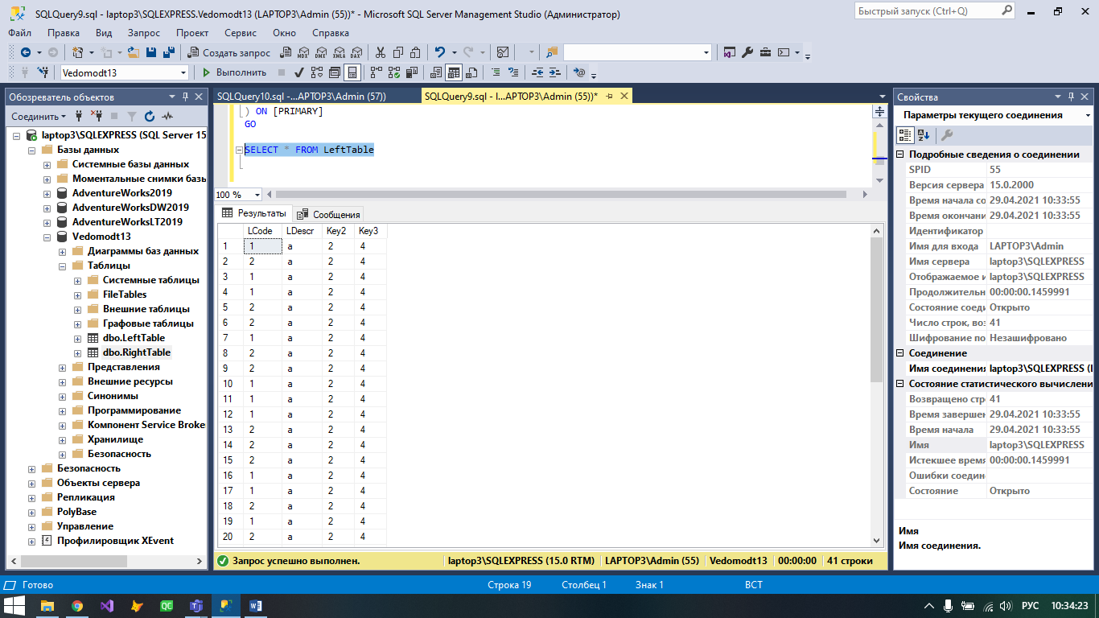

SELECT * FROM RightTable

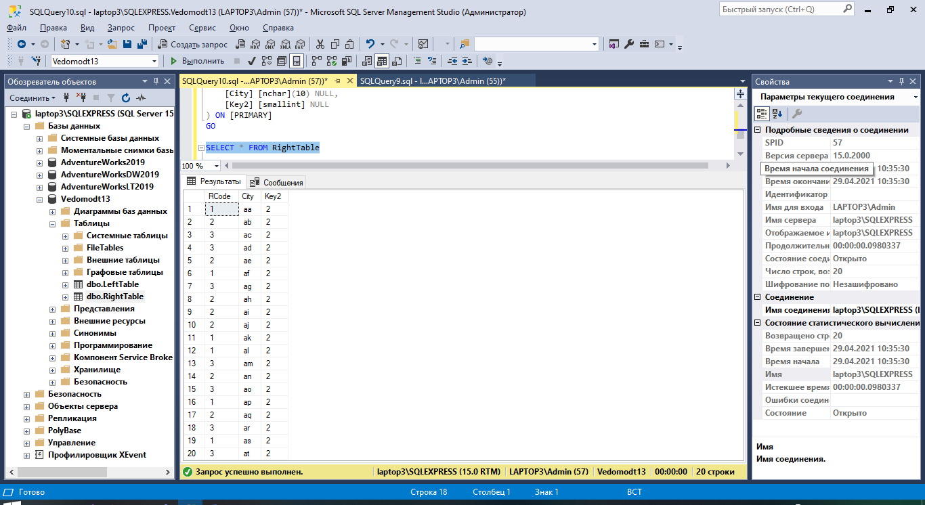

SELECT l.*, r.*

FROM LeftTable l

JOIN RightTable r ON l.LCode = r.RCode

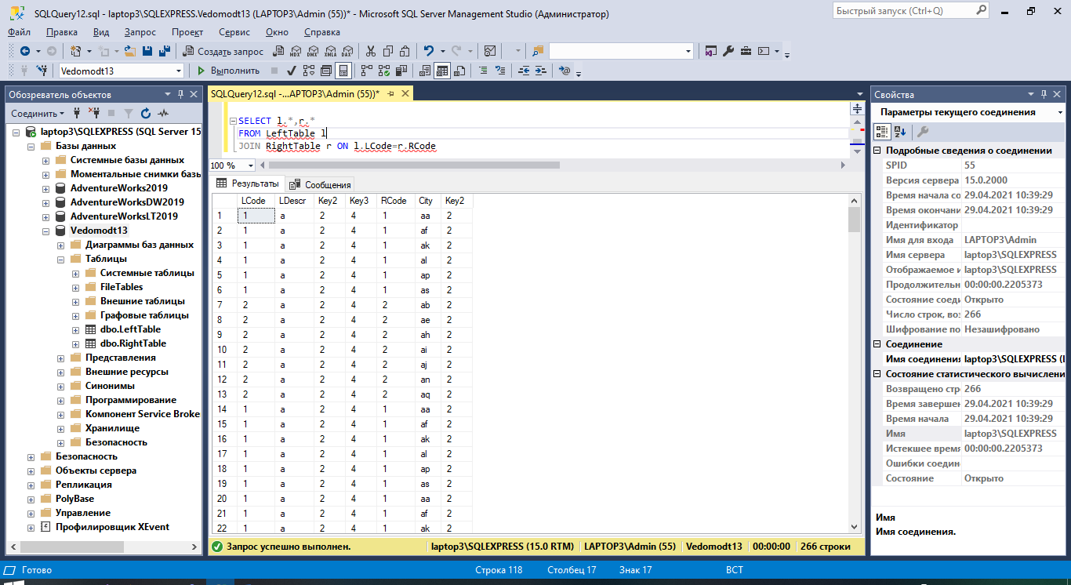

SELECT l.*, r.*

FROM LeftTable l

LEFT JOIN RightTable r ON l.LCode = r.RCode

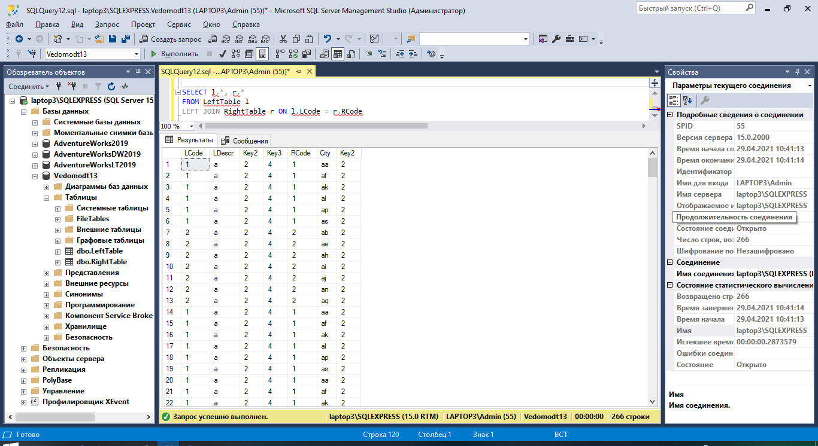

SELECT l.*, r.*

FROM LeftTable l

RIGHT JOIN RightTable r ON l.LCode = r.RCode

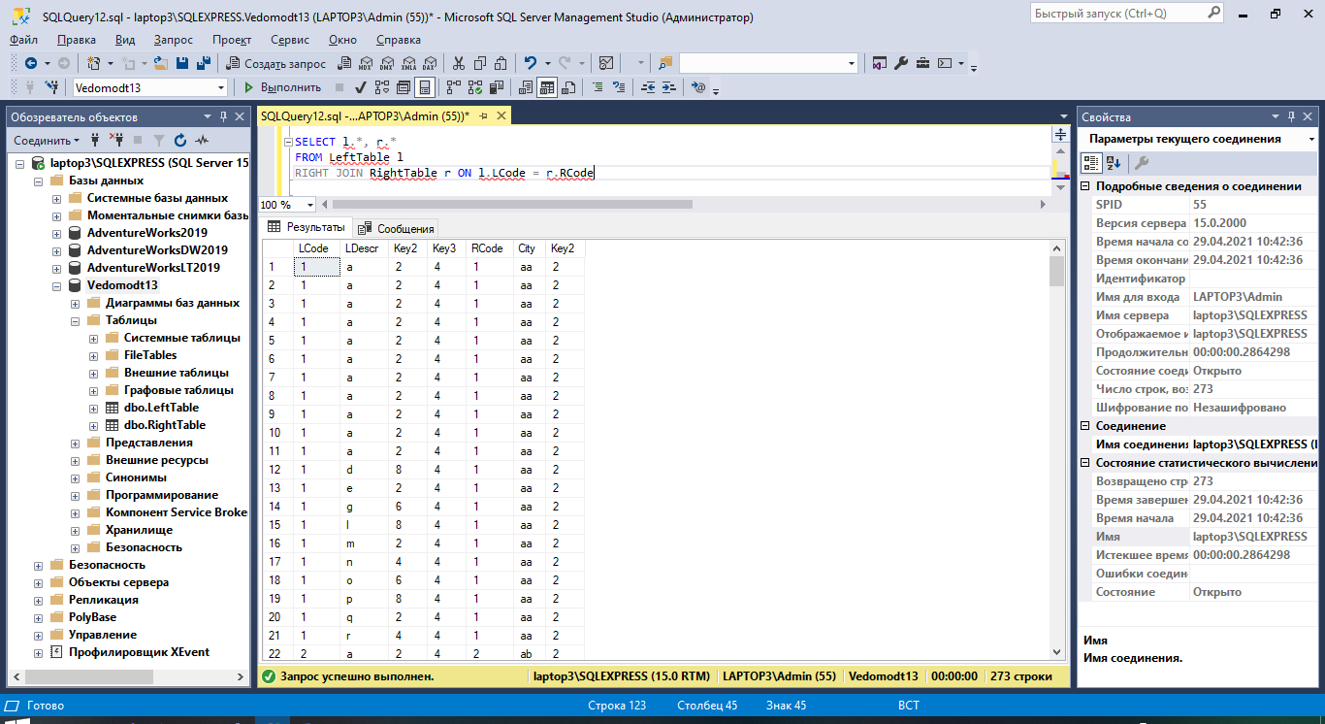

SELECT l.*, r.*

FROM LeftTable l

FULL JOIN RightTable r ON l.LCode = r.RCode

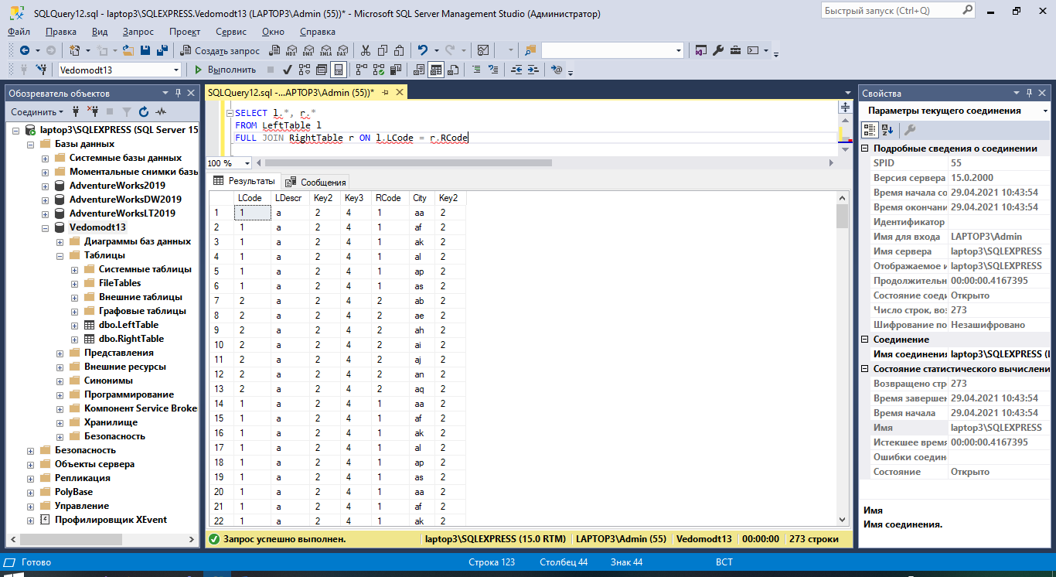

SELECT l.*, r.*

FROM LeftTable l

CROSS JOIN RightTable r

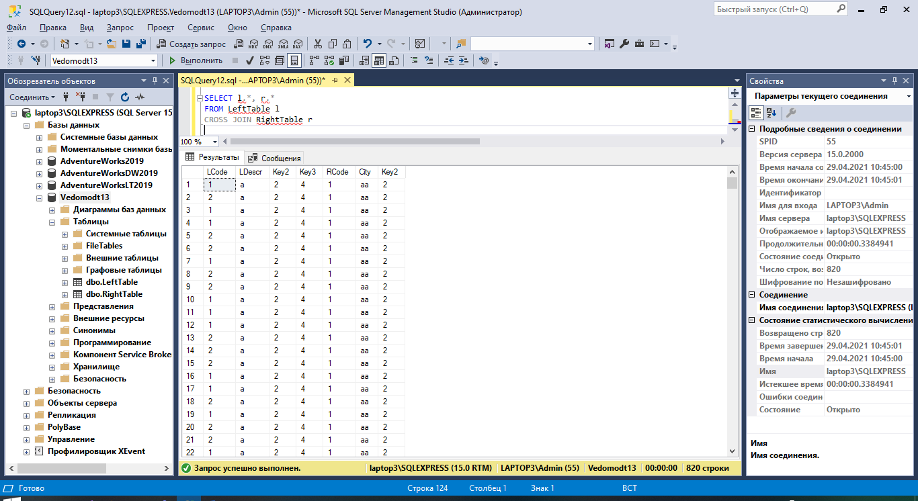

**Создание JOIN-соединения с использованием неравенства**

SELECT l.Key3,

l.LCode AS Name,

l.Key2 AS LKey2,

r.Key2 AS RKey2,

r.City AS City

FROM LeftTable l

INNER JOIN RightTable r ON l.Key2 <= r.Key2

WHERE l.Key3 = 4;

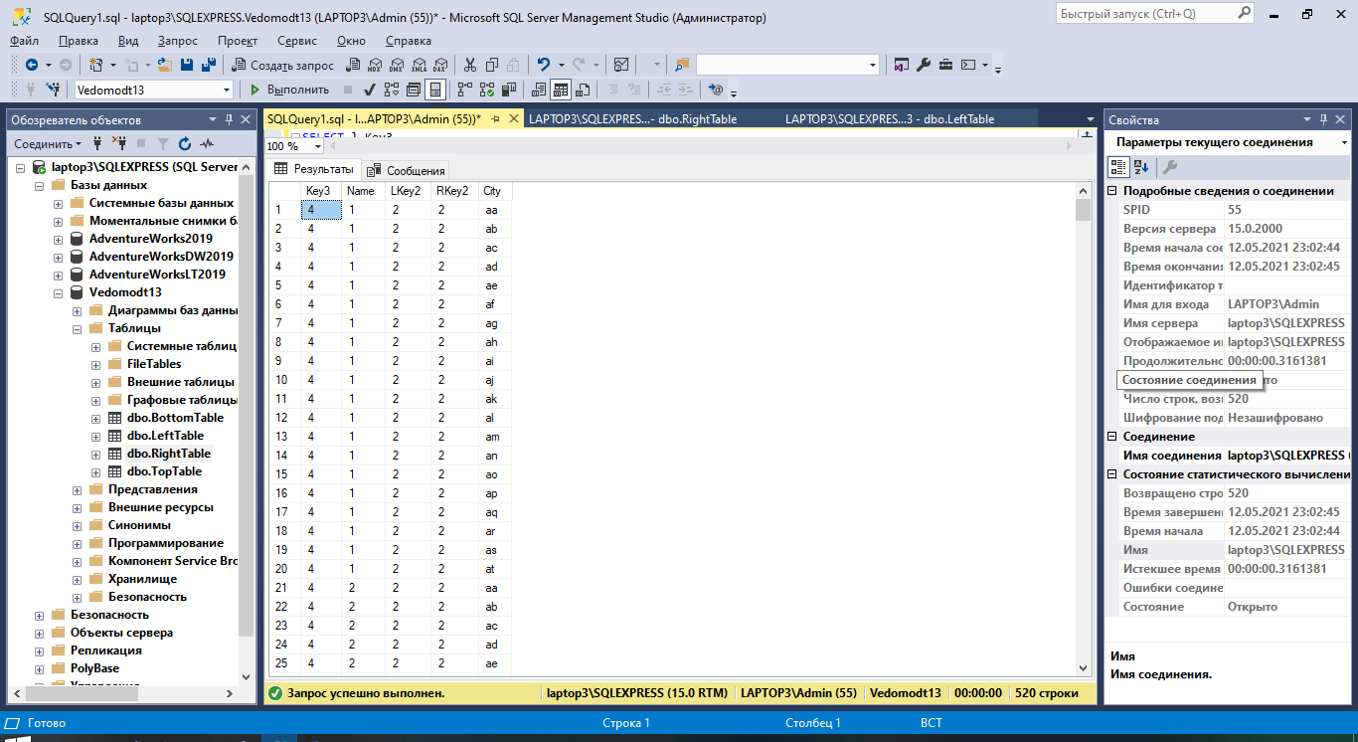

**Скрипт создания таблиц TopTable и BottomTable**

**TopTable:**

USE [Vedomodt13]

GO

/****** Object: Table [dbo].[TopTable] Script Date: 12.05.2021 23:07:02 ******/

SET ANSI_NULLS ON

GO

SET QUOTED_IDENTIFIER ON

GO

CREATE TABLE [dbo].[TopTable](

[T1] [smallint] NULL,

[T2] [nchar](10) NULL

) ON [PRIMARY]

GO

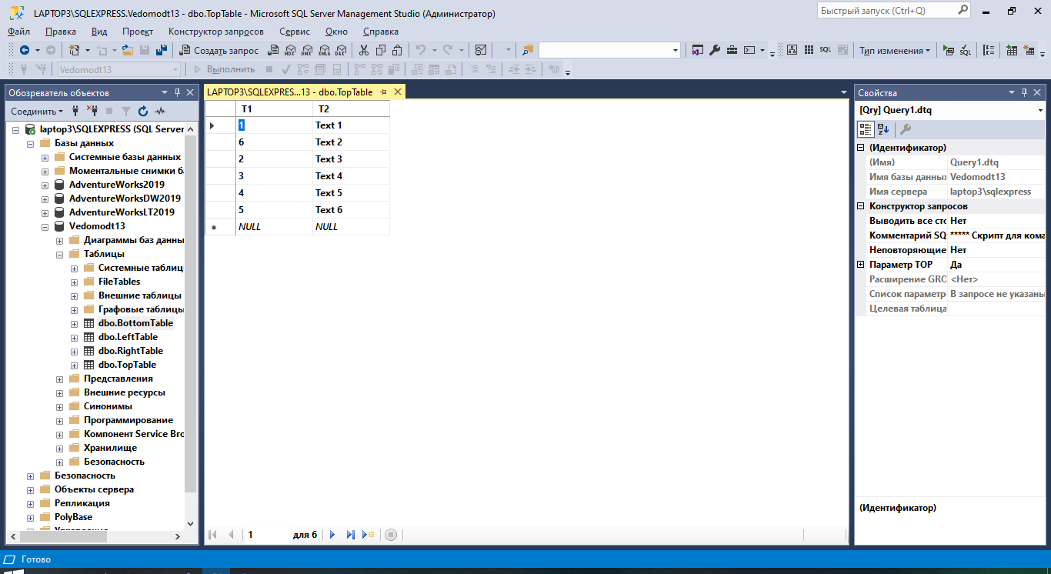

**BottomTable:**

USE [Vedomodt13]

GO

/****** Object: Table [dbo].[BottomTable] Script Date: 12.05.2021 23:07:43 ******/

SET ANSI_NULLS ON

GO

SET QUOTED_IDENTIFIER ON

GO

CREATE TABLE [dbo].[BottomTable](

[B1] [smallint] NULL,

[B2] [nchar](10) NULL

) ON [PRIMARY]

GO

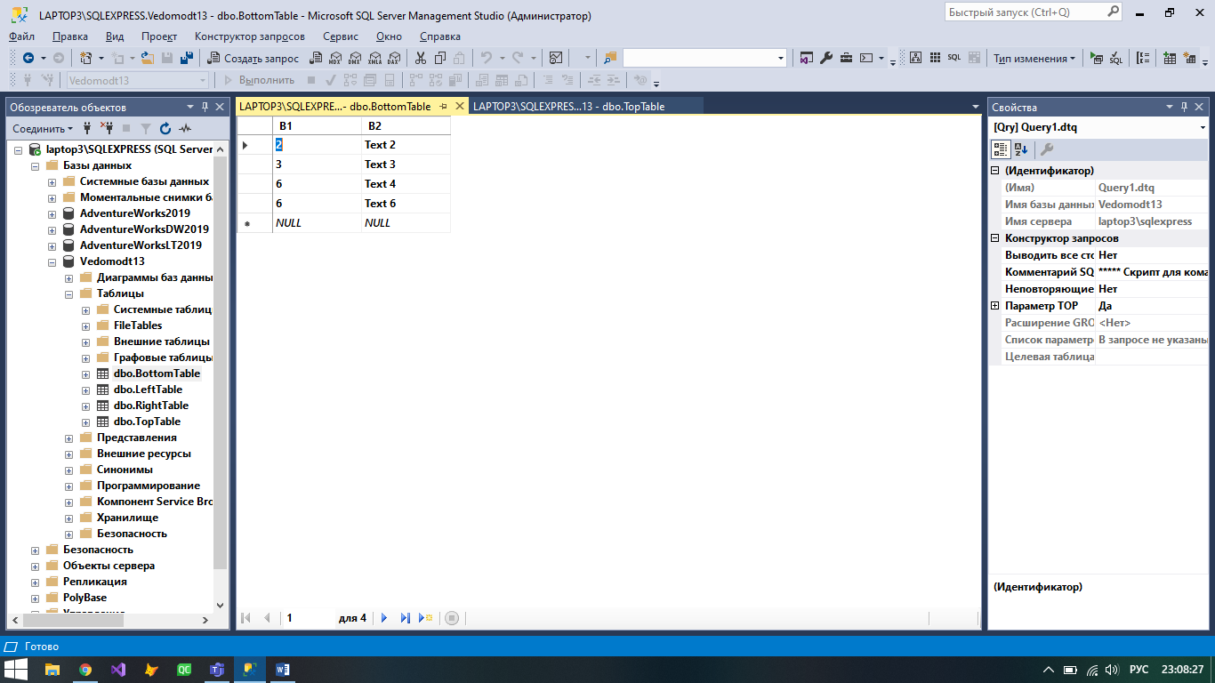

**Выполнение операторов вертикального объединения UNION, EXCEPT и INTERSECT**

SELECT T1 x, T2 y

FROM TopTable

UNION ALL

SELECT B1, B2

FROM BottomTable

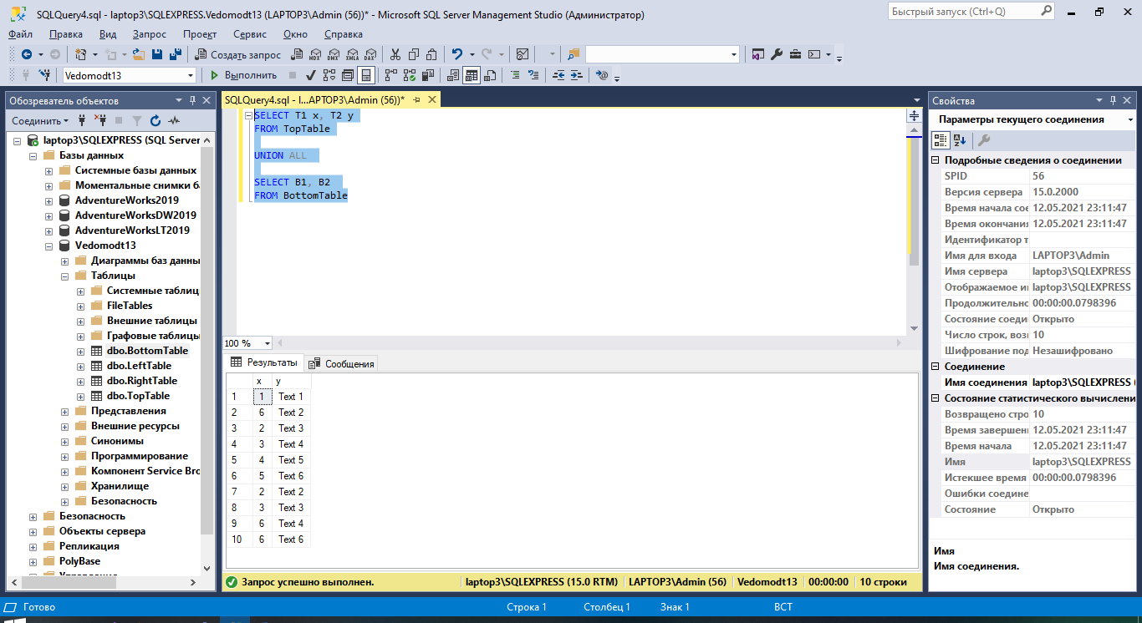

SELECT T1 x, T2 y

FROM TopTable

UNION

SELECT B1, B2

FROM BottomTable

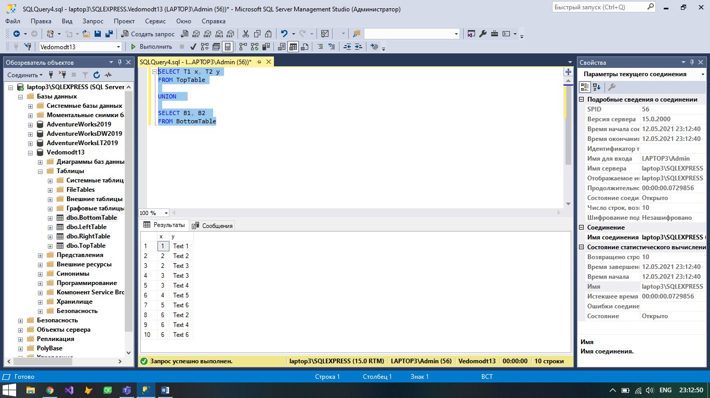

SELECT T1 x, T2 y

FROM TopTable

EXCEPT

SELECT B1, B2

FROM BottomTable

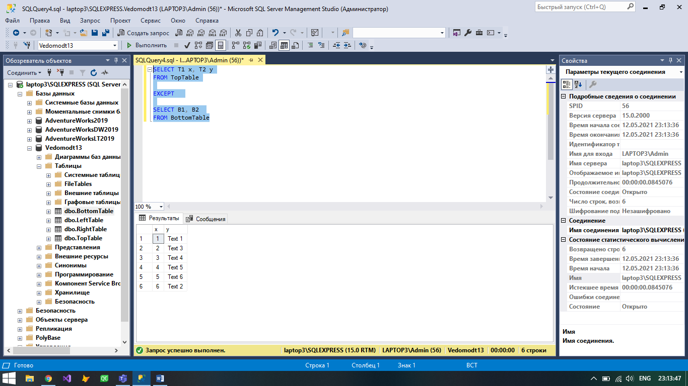

SELECT T1 x, T2 y

FROM TopTable

INTERSECT

SELECT B1, B2

FROM BottomTable

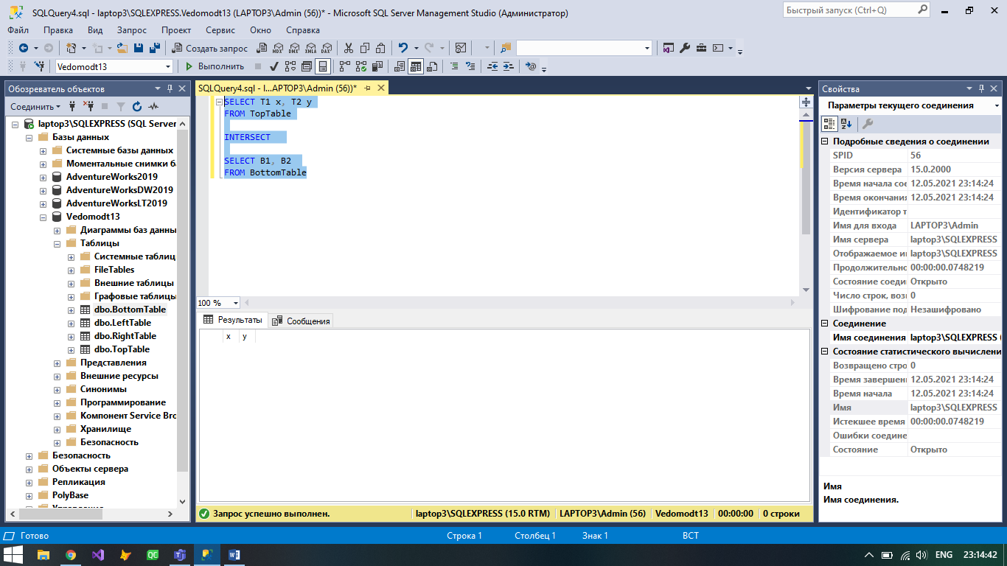

**Создание таблиц Students3c и Teachers**

**Students3c:**

USE [Vedomodt13]

GO

/****** Object: Table [dbo].[Students3c] Script Date: 12.05.2021 23:26:24 ******/

SET ANSI_NULLS ON

GO

SET QUOTED_IDENTIFIER ON

GO

CREATE TABLE [dbo].[Students3c](

[IDStudent] [smallint] NOT NULL,

[Gr] [nchar](10) NULL,

[SSurName] [nchar](10) NULL,

[SName] [nchar](10) NULL,

[SLastName] [nchar](10) NULL,

[NZach] [nchar](10) NULL,

[SKaf] [nchar](10) NULL,

[GradYear] [nchar](10) NULL,

CONSTRAINT [PK_Students3c] PRIMARY KEY CLUSTERED

(

[IDStudent] ASC

)WITH (PAD_INDEX = OFF, STATISTICS_NORECOMPUTE = OFF, IGNORE_DUP_KEY = OFF, ALLOW_ROW_LOCKS = ON, ALLOW_PAGE_LOCKS = ON, OPTIMIZE_FOR_SEQUENTIAL_KEY = OFF) ON [PRIMARY]

) ON [PRIMARY]

GO

**Teachers:**

USE [Vedomodt13]

GO

/****** Object: Table [dbo].[Teachers] Script Date: 12.05.2021 23:26:48 ******/

SET ANSI_NULLS ON

GO

SET QUOTED_IDENTIFIER ON

GO

CREATE TABLE [dbo].[Teachers](

[IDTeacher] [smallint] NOT NULL,

[TSurName] [nchar](10) NULL,

[TName] [nchar](10) NULL,

[TLastName] [nchar](10) NULL,

[TKaf] [nchar](10) NULL,

CONSTRAINT [PK_Teachers] PRIMARY KEY CLUSTERED

(

[IDTeacher] ASC

)WITH (PAD_INDEX = OFF, STATISTICS_NORECOMPUTE = OFF, IGNORE_DUP_KEY = OFF, ALLOW_ROW_LOCKS = ON, ALLOW_PAGE_LOCKS = ON, OPTIMIZE_FOR_SEQUENTIAL_KEY = OFF) ON [PRIMARY]

) ON [PRIMARY]

GO

**Заполнение таблиц:**

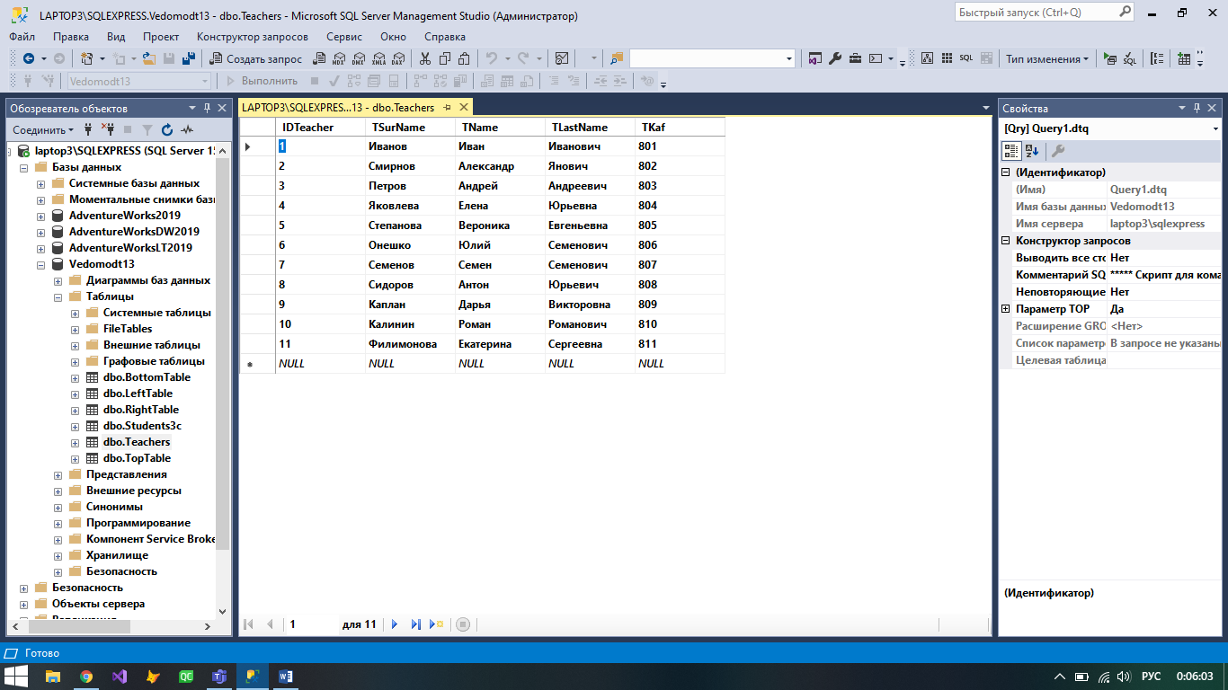

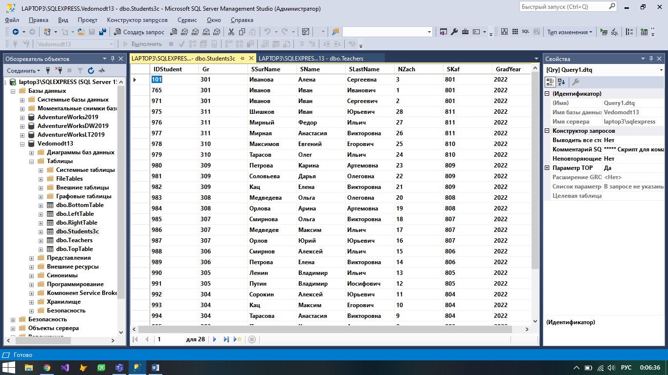

**Выполнение запросов**

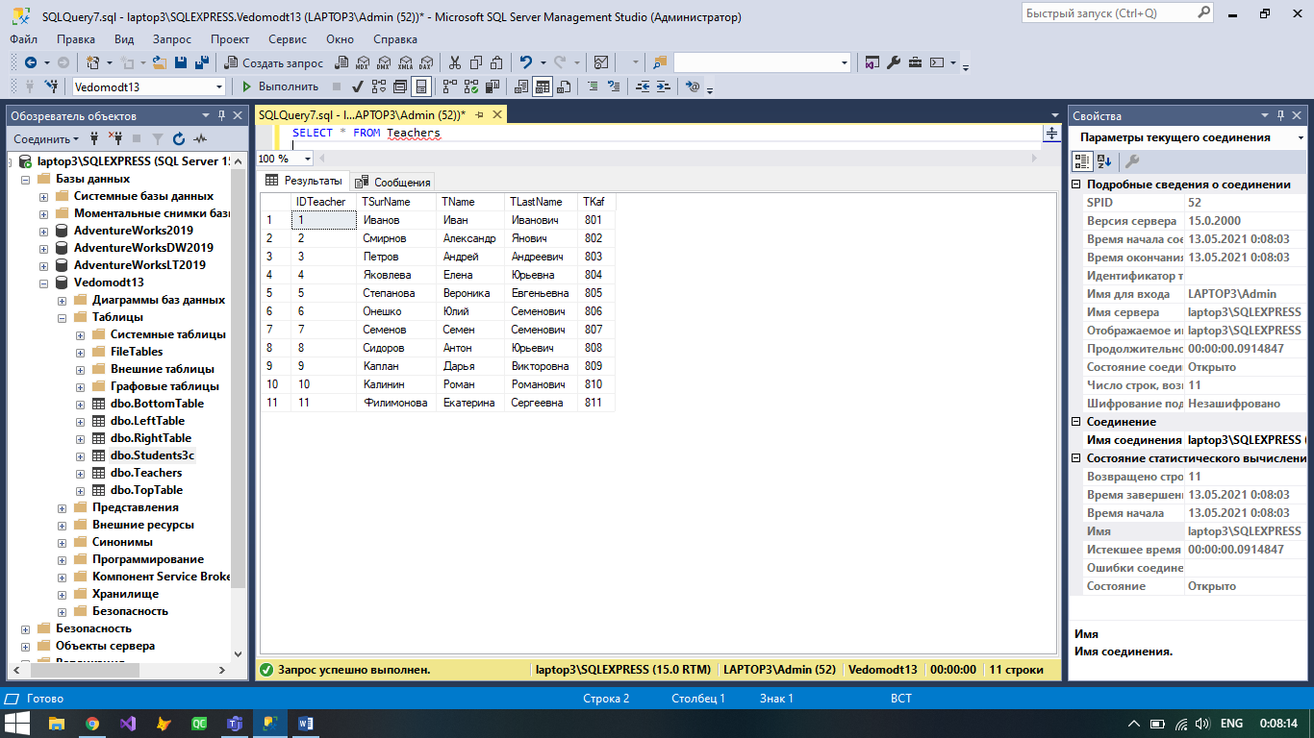

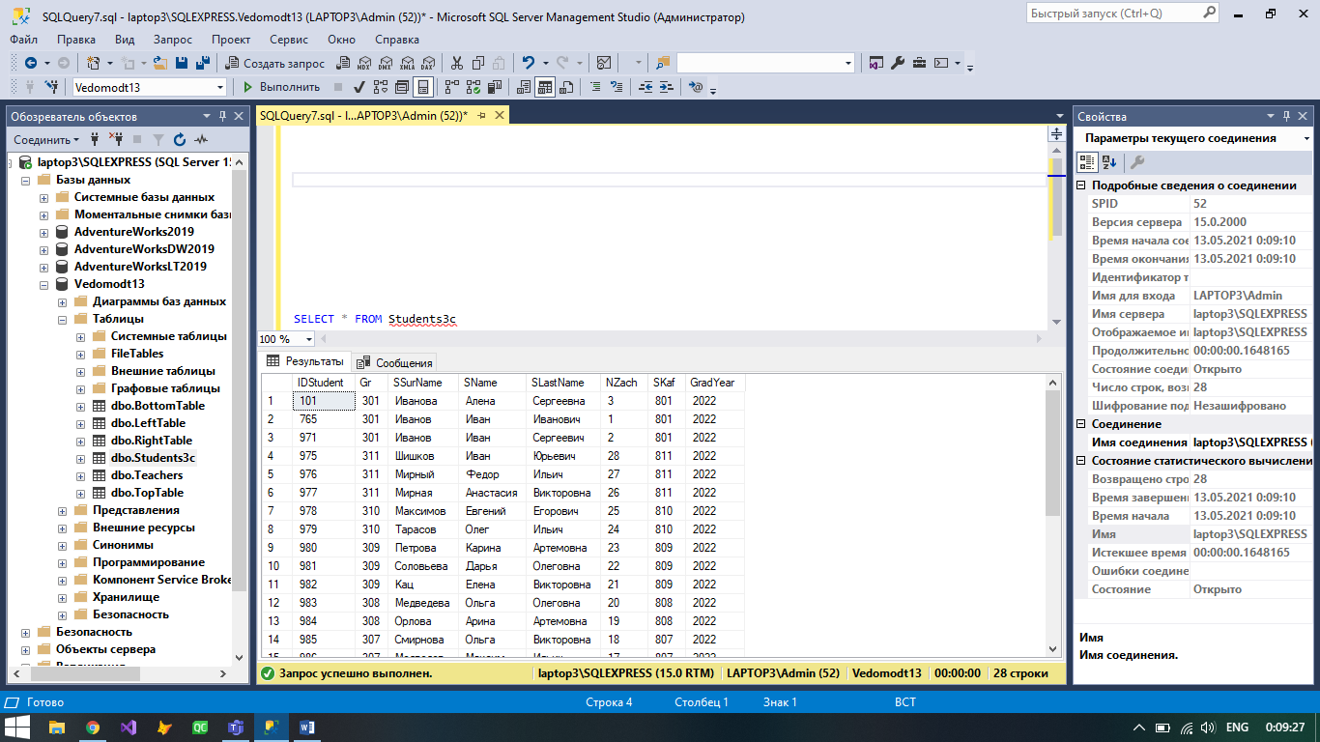

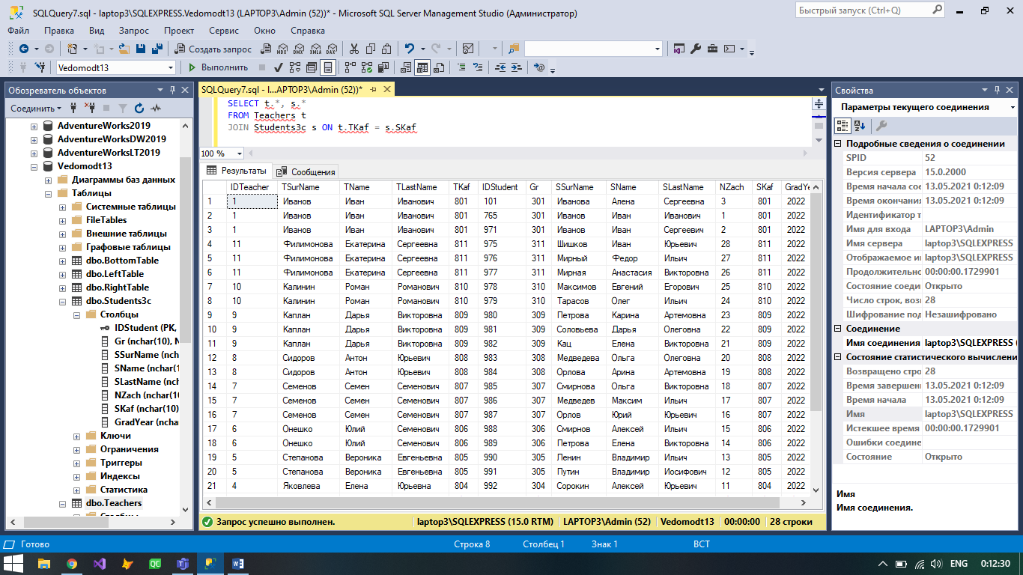

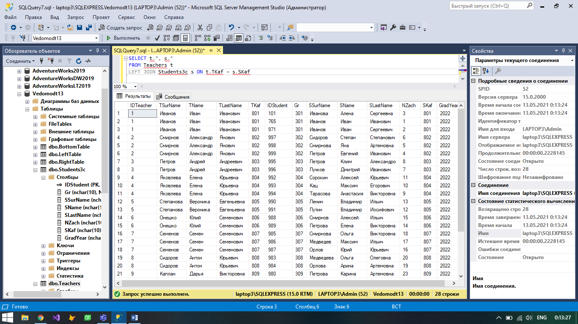

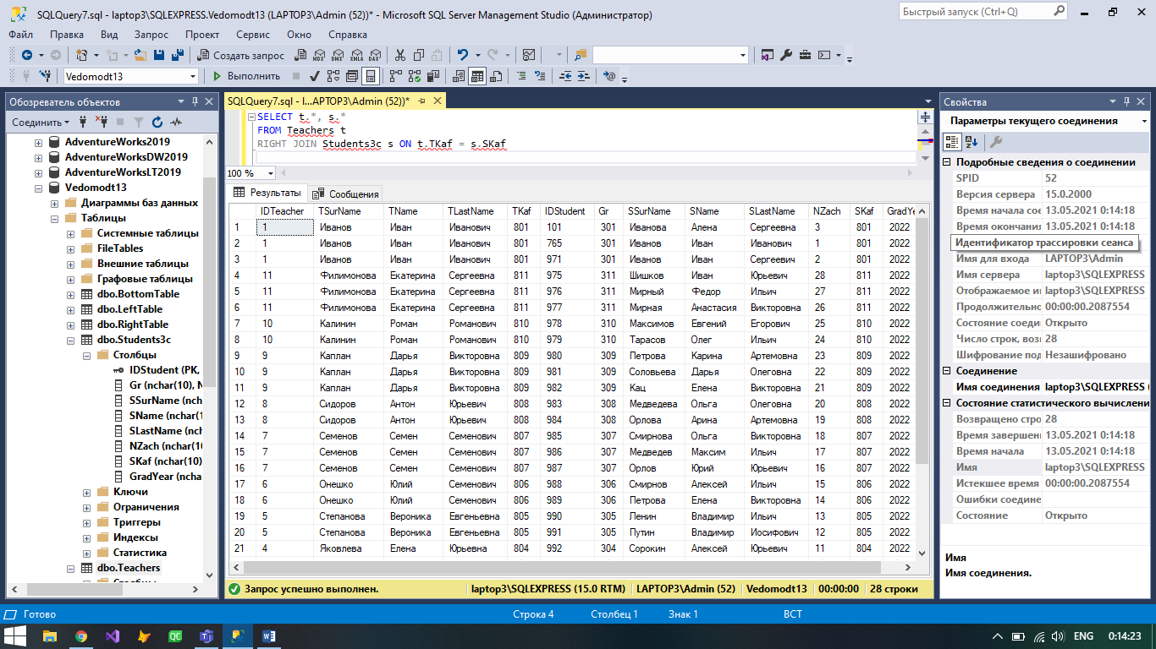

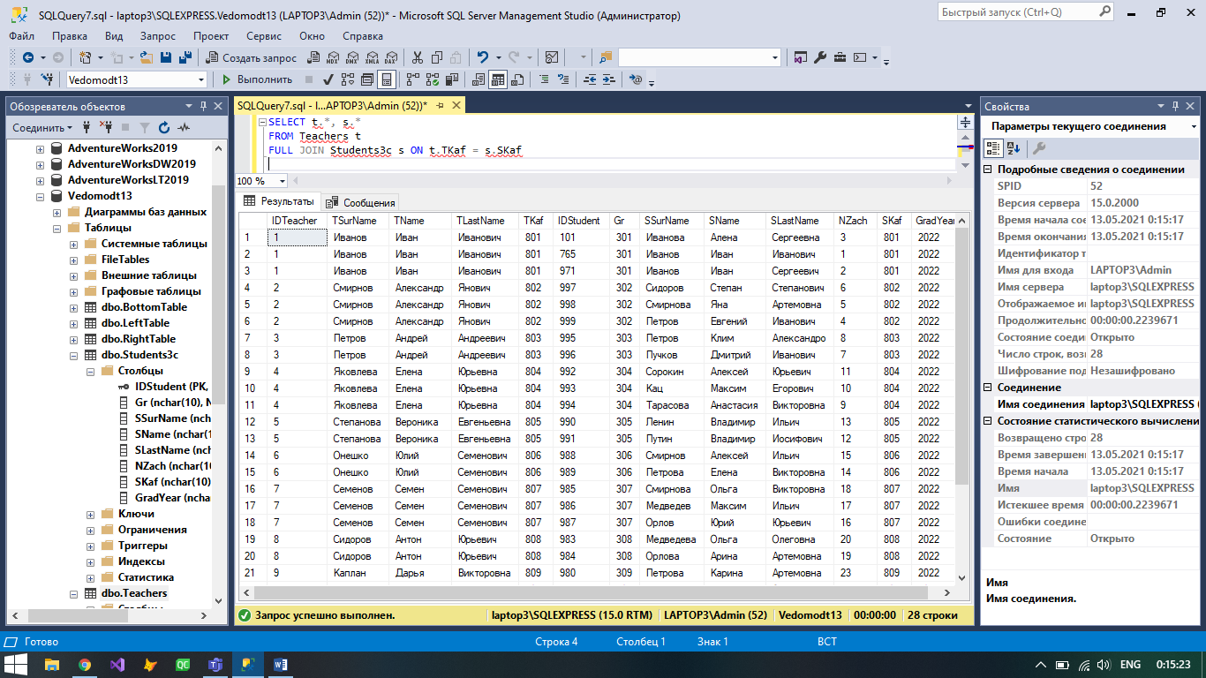

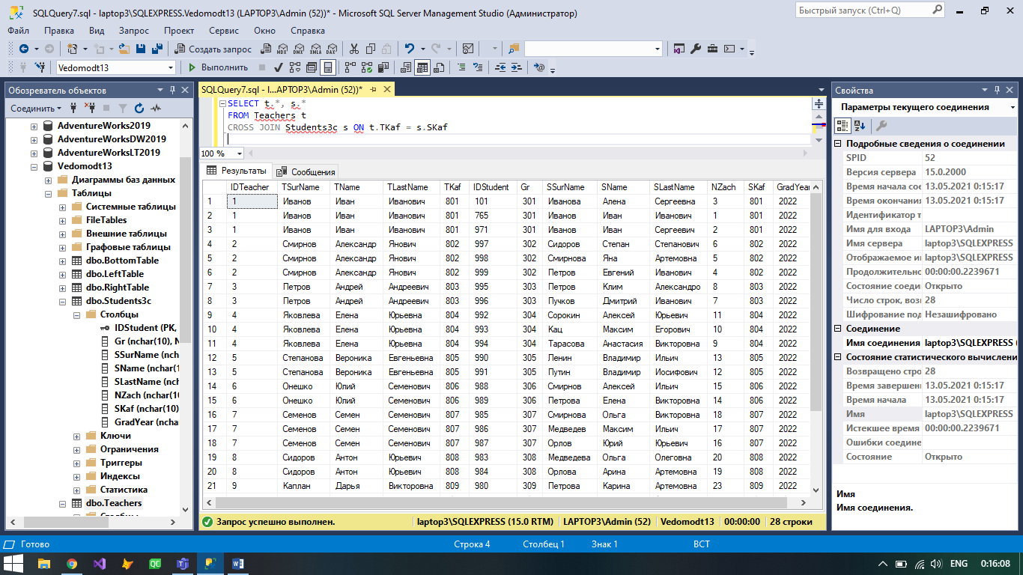

**Скрипты создания таблиц с ограничениями внешнего ключа: Teachers, Students4c, Disciplines, Grades**

**Teachers:**

USE [Vedomodt13]

GO

/****** Object: Table [dbo].[Teachers] Script Date: 13.05.2021 2:17:16 ******/

SET ANSI_NULLS ON

GO

SET QUOTED_IDENTIFIER ON

GO

CREATE TABLE [dbo].[Teachers](

[IDTeacher] [smallint] NOT NULL,

[TSurName] [nchar](10) NULL,

[TName] [nchar](10) NULL,

[TLastName] [nchar](10) NULL,

[TKaf] [nchar](10) NULL,

CONSTRAINT [PK_Teachers] PRIMARY KEY CLUSTERED

(

[IDTeacher] ASC

)WITH (PAD_INDEX = OFF, STATISTICS_NORECOMPUTE = OFF, IGNORE_DUP_KEY = OFF, ALLOW_ROW_LOCKS = ON, ALLOW_PAGE_LOCKS = ON, OPTIMIZE_FOR_SEQUENTIAL_KEY = OFF) ON [PRIMARY]

) ON [PRIMARY]

GO

ALTER TABLE [dbo].[Teachers] WITH CHECK ADD CONSTRAINT [FK_Teachers_Teachers] FOREIGN KEY([IDTeacher])

REFERENCES [dbo].[Teachers] ([IDTeacher])

GO

ALTER TABLE [dbo].[Teachers] CHECK CONSTRAINT [FK_Teachers_Teachers]

GO

**Students4c:**

USE [Vedomodt13]

GO

/****** Object: Table [dbo].[Students4c] Script Date: 13.05.2021 2:17:51 ******/

SET ANSI_NULLS ON

GO

SET QUOTED_IDENTIFIER ON

GO

CREATE TABLE [dbo].[Students4c](

[IDStudent4] [smallint] NOT NULL,

[Gr] [nchar](10) NULL,

[SSurName] [nchar](10) NULL,

[SName] [nchar](10) NULL,

[SLastName] [nchar](10) NULL,

[NZach] [nchar](10) NULL,

[SKaf] [nchar](10) NULL,

[GradYear] [nchar](10) NULL,

CONSTRAINT [PK_Students4c] PRIMARY KEY CLUSTERED

(

[IDStudent4] ASC

)WITH (PAD_INDEX = OFF, STATISTICS_NORECOMPUTE = OFF, IGNORE_DUP_KEY = OFF, ALLOW_ROW_LOCKS = ON, ALLOW_PAGE_LOCKS = ON, OPTIMIZE_FOR_SEQUENTIAL_KEY = OFF) ON [PRIMARY]

) ON [PRIMARY]

GO

ALTER TABLE [dbo].[Students4c] WITH CHECK ADD CONSTRAINT [FK_Students4c_Students4c] FOREIGN KEY([IDStudent4])

REFERENCES [dbo].[Students4c] ([IDStudent4])

GO

ALTER TABLE [dbo].[Students4c] CHECK CONSTRAINT [FK_Students4c_Students4c]

GO

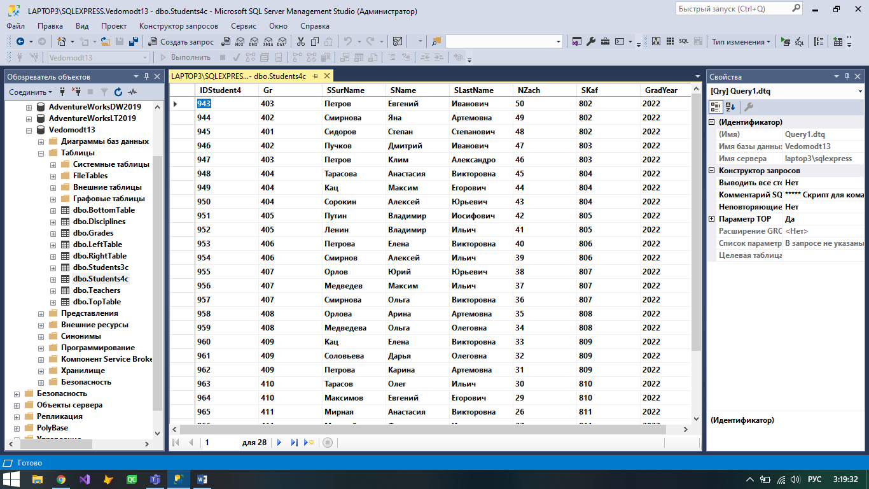

**Disciplines:**

USE [Vedomodt13]

GO

/****** Object: Table [dbo].[Students4c] Script Date: 13.05.2021 2:17:51 ******/

SET ANSI_NULLS ON

GO

SET QUOTED_IDENTIFIER ON

GO

CREATE TABLE [dbo].[Students4c](

[IDStudent4] [smallint] NOT NULL,

[Gr] [nchar](10) NULL,

[SSurName] [nchar](10) NULL,

[SName] [nchar](10) NULL,

[SLastName] [nchar](10) NULL,

[NZach] [nchar](10) NULL,

[SKaf] [nchar](10) NULL,

[GradYear] [nchar](10) NULL,

CONSTRAINT [PK_Students4c] PRIMARY KEY CLUSTERED

(

[IDStudent4] ASC

)WITH (PAD_INDEX = OFF, STATISTICS_NORECOMPUTE = OFF, IGNORE_DUP_KEY = OFF, ALLOW_ROW_LOCKS = ON, ALLOW_PAGE_LOCKS = ON, OPTIMIZE_FOR_SEQUENTIAL_KEY = OFF) ON [PRIMARY]

) ON [PRIMARY]

GO

ALTER TABLE [dbo].[Students4c] WITH CHECK ADD CONSTRAINT [FK_Students4c_Students4c] FOREIGN KEY([IDStudent4])

REFERENCES [dbo].[Students4c] ([IDStudent4])

GO

ALTER TABLE [dbo].[Students4c] CHECK CONSTRAINT [FK_Students4c_Students4c]

GO

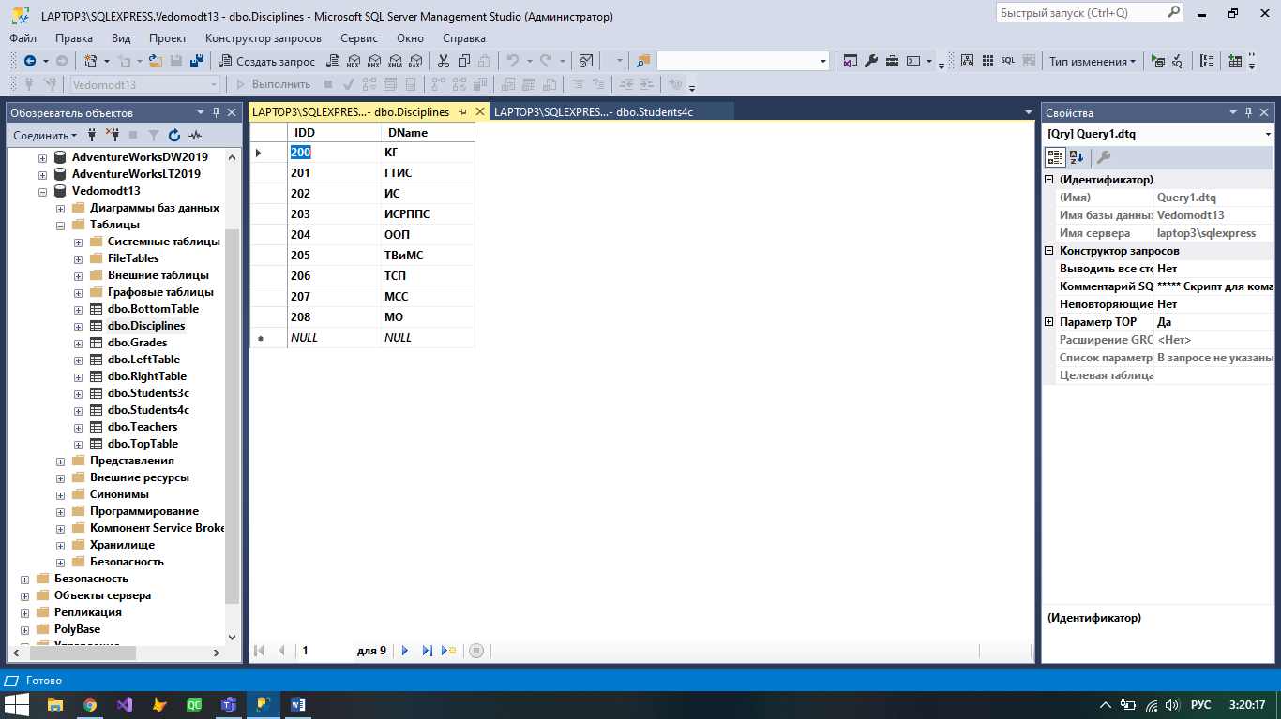

**Grades (содержит ограничение внешнего ключа и ограничение CHECK на значения столбца с оценками):**

USE [Vedomodt13]

GO

/****** Object: Table [dbo].[Grades] Script Date: 13.05.2021 2:19:31 ******/

SET ANSI_NULLS ON

GO

SET QUOTED_IDENTIFIER ON

GO

CREATE TABLE [dbo].[Grades](

[ID] [smallint] NOT NULL,

[FS] [smallint] NULL,

[FD] [smallint] NULL,

[FT] [smallint] NULL,

[Grade] [nchar](10) NULL,

[Date] [smalldatetime] NULL,

CONSTRAINT [PK_Grades] PRIMARY KEY CLUSTERED

(

[ID] ASC

)WITH (PAD_INDEX = OFF, STATISTICS_NORECOMPUTE = OFF, IGNORE_DUP_KEY = OFF, ALLOW_ROW_LOCKS = ON, ALLOW_PAGE_LOCKS = ON, OPTIMIZE_FOR_SEQUENTIAL_KEY = OFF) ON [PRIMARY]

) ON [PRIMARY]

GO

ALTER TABLE [dbo].[Grades] WITH CHECK ADD CONSTRAINT [FK_Grades_Disciplines] FOREIGN KEY([FD])

REFERENCES [dbo].[Disciplines] ([IDD])

GO

ALTER TABLE [dbo].[Grades] CHECK CONSTRAINT [FK_Grades_Disciplines]

GO

ALTER TABLE [dbo].[Grades] WITH CHECK ADD CONSTRAINT [FK_Grades_Students4c] FOREIGN KEY([FS])

REFERENCES [dbo].[Students4c] ([IDStudent4])

GO

ALTER TABLE [dbo].[Grades] CHECK CONSTRAINT [FK_Grades_Students4c]

GO

ALTER TABLE [dbo].[Grades] WITH CHECK ADD CONSTRAINT [FK_Grades_Teachers] FOREIGN KEY([FT])

REFERENCES [dbo].[Teachers] ([IDTeacher])

GO

ALTER TABLE [dbo].[Grades] CHECK CONSTRAINT [FK_Grades_Teachers]

GO

ALTER TABLE [dbo].[Grades] WITH CHECK ADD CONSTRAINT [CK_Grades] CHECK (([Grade]>=(2) AND [Grade]<=(5)))

GO

ALTER TABLE [dbo].[Grades] CHECK CONSTRAINT [CK_Grades]

GO

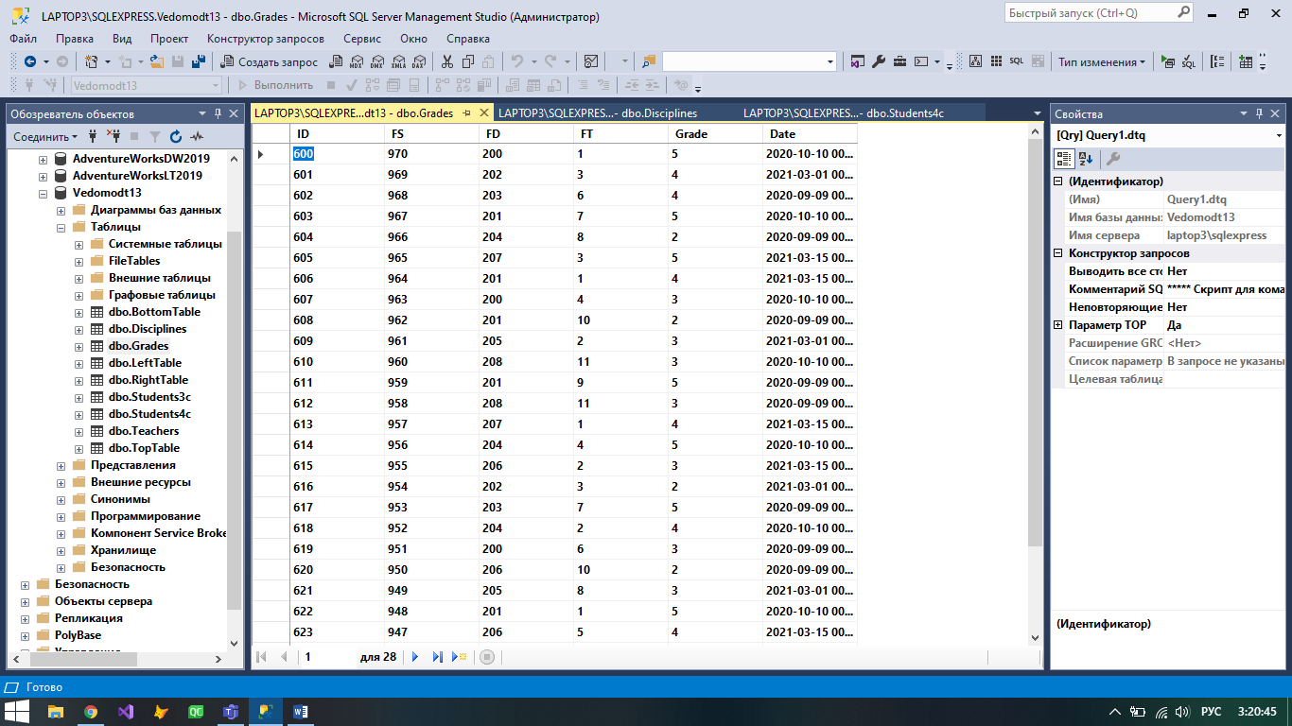

**Вертикальные объединения Students3c и Students4c**

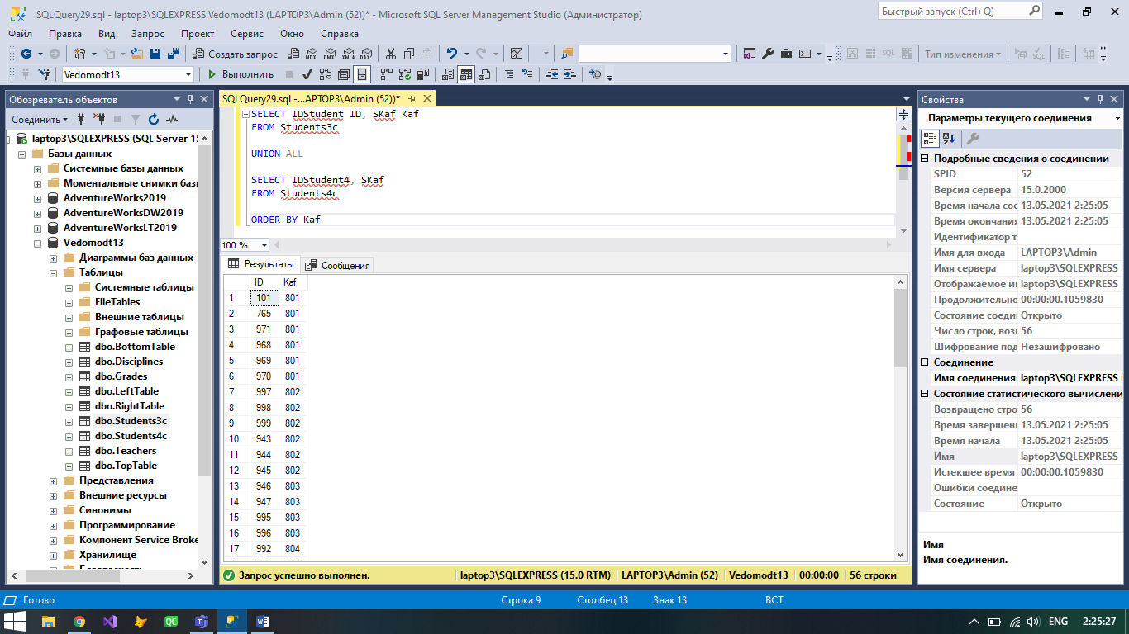

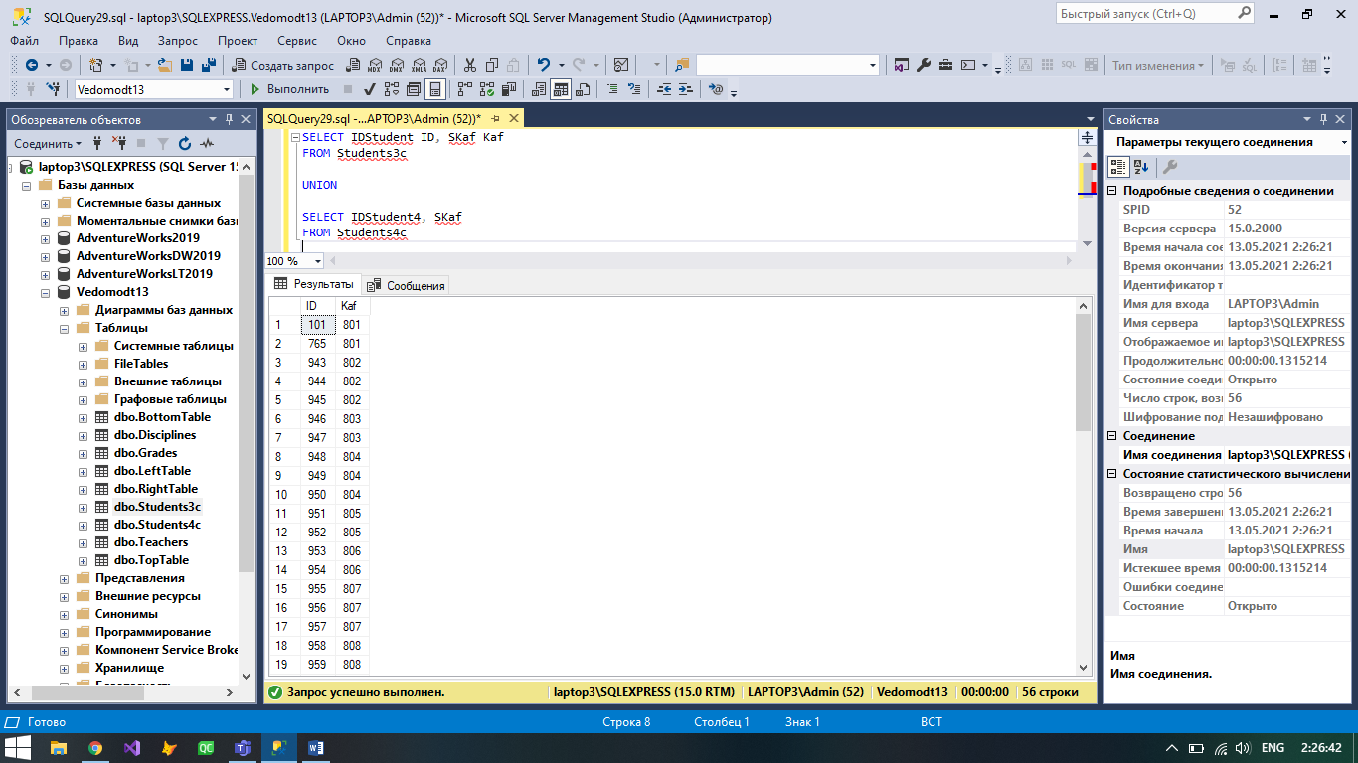

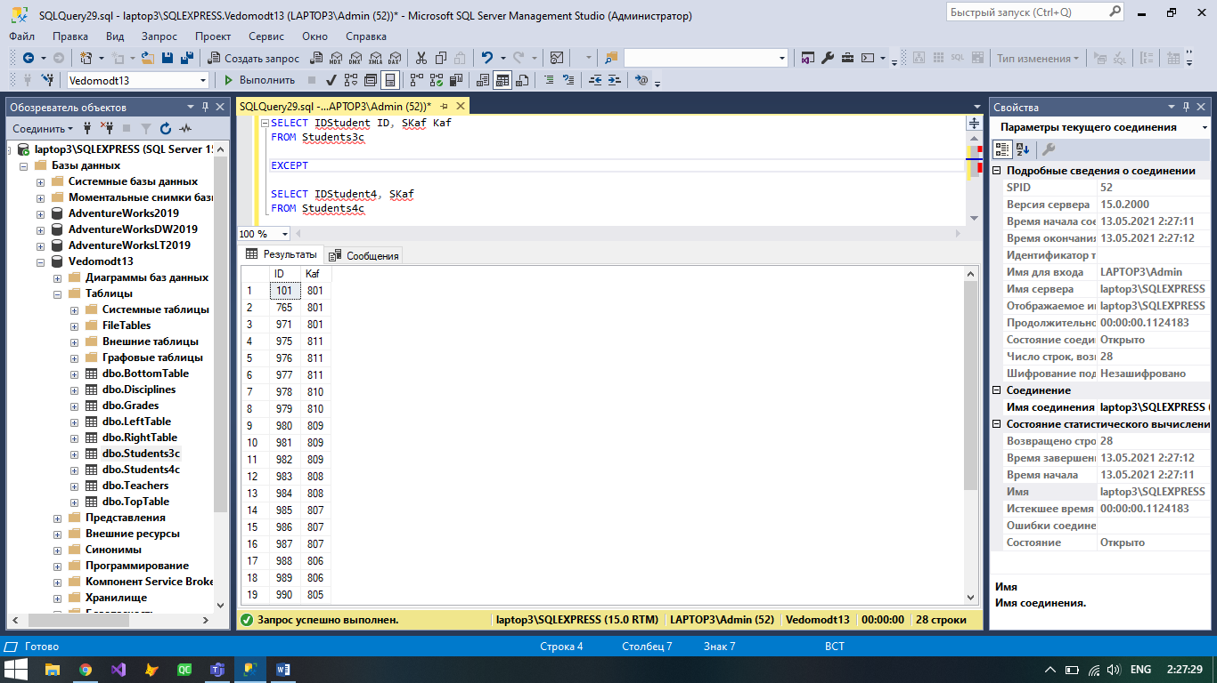

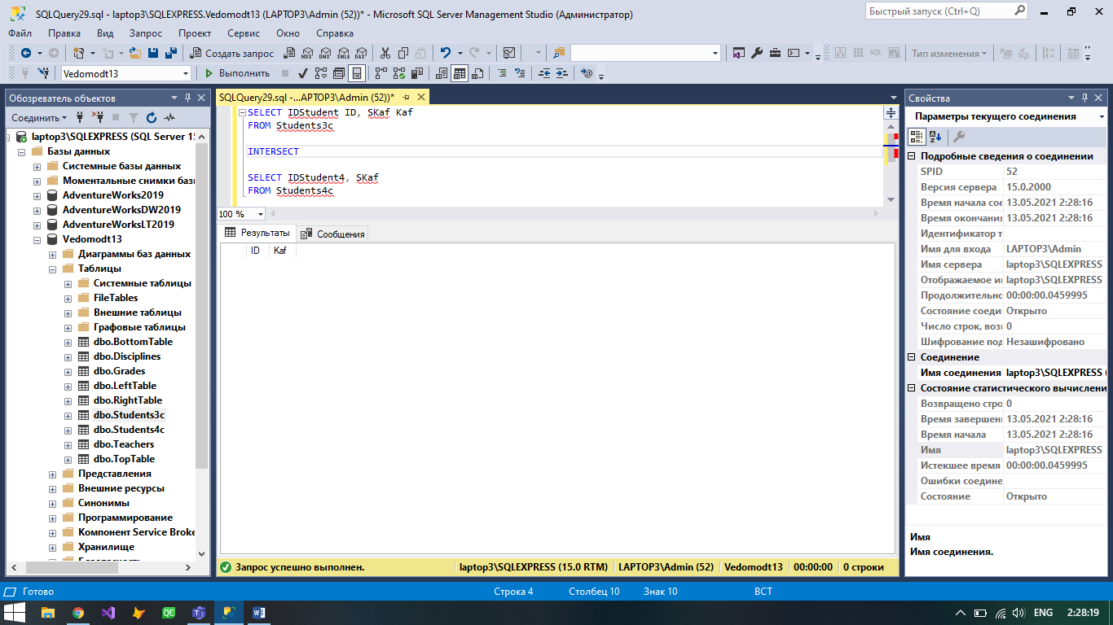

**Множественное JOIN-соединение таблиц: Оценки, Студенты, Дисциплины, Преподаватели**

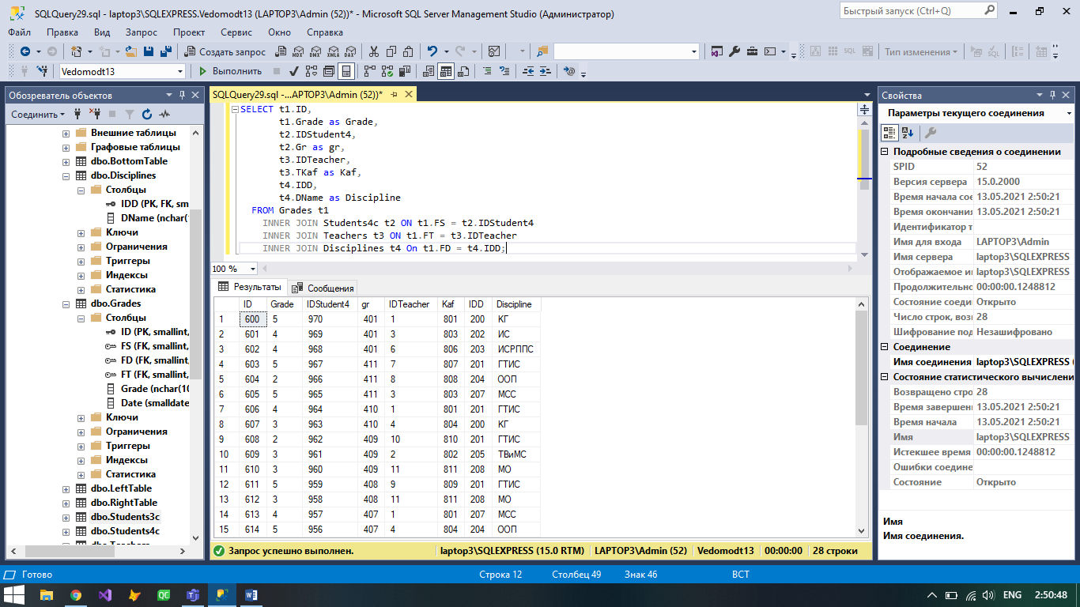

**JOIN-соединение для получения исключения пересечения таблиц LeftTable и RightTable**

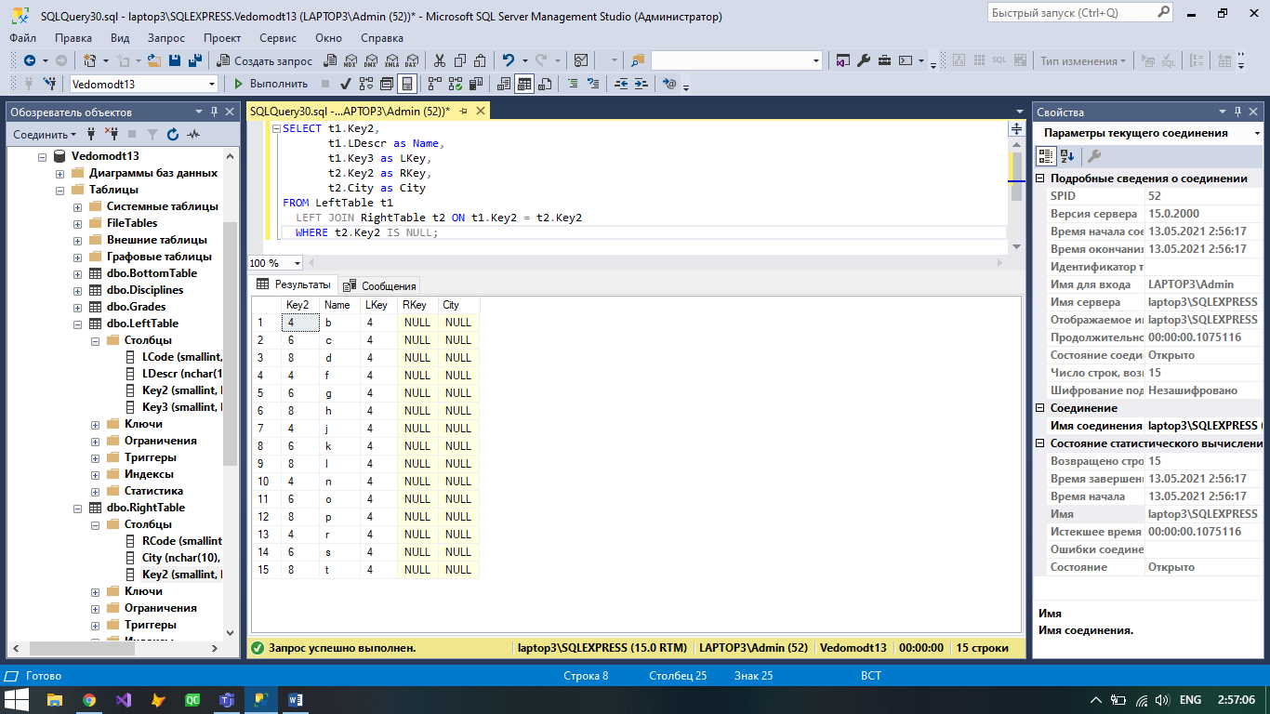

**Запрос «Оценки по ИС»**

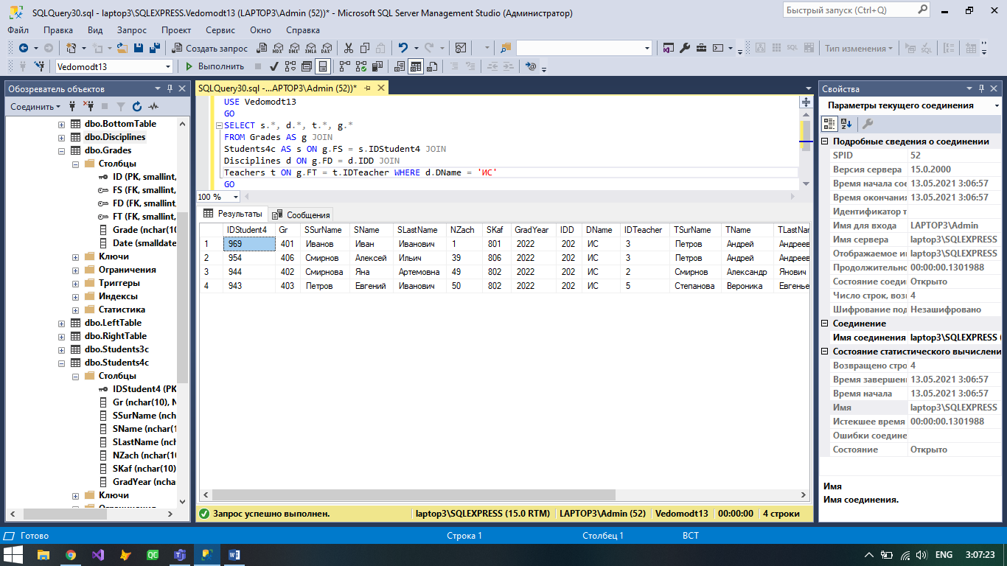

**План выполнения SELECT-запроса**

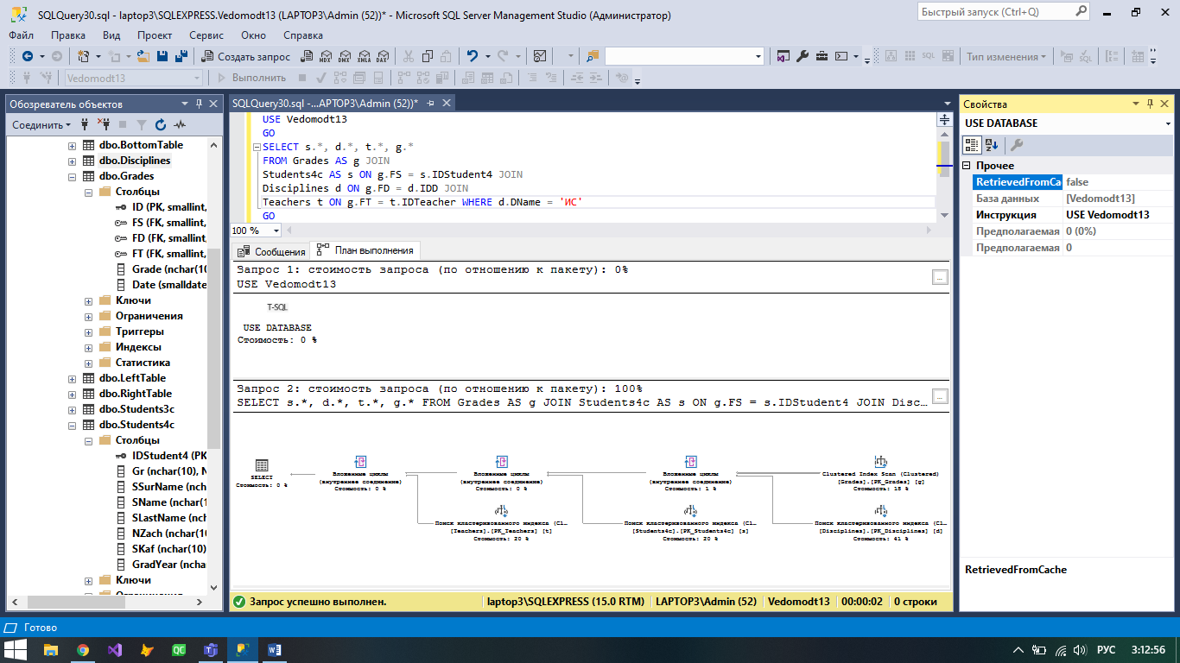

**Создание представления View на основе SELECT-запроса**

